2011年北京市高级中等学校招生考试
英 语 试 卷

学校__________________ 姓名_____________ 准考证号_________________
考生须知 | 1. 本试卷共12页，满分120分，考试时间120分钟。  2. 在试卷和答题卡上准确填写学校名称、姓名和准考证号。  3. 试题答案一律填涂或书写在答题卡上，在试卷上作答无效。  4. 在答题卡上，选择题用2B铅笔作答，其他试题用黑色字迹签字笔作答。  5. 考试结束，请将本试卷和答题卡一并交回。

听力理解（共24分）

一、听对话，从下面各题所给的A、B、C三幅图片中选择与对话内容相符的图片。每段对话读两遍。（共4分，每小题1分）
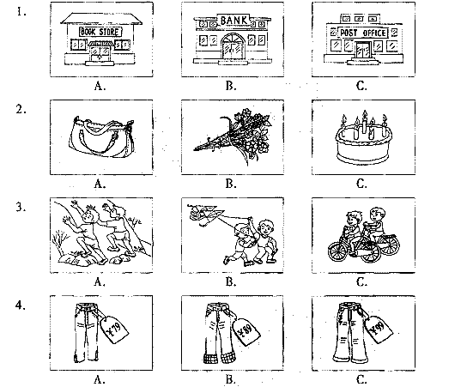

二、听对话或独白，根据对话或独白的内容，从下面各题所给的A、B、C三个选项中选择最佳选项。每段对话或独白读两遍。（共12分，每小题1分）
请听一段对话，完成第5至第6小题。
5. Who’s Mary?
A. Peter’s classmate. B. Peter’s sister. C. Peter’s neighbor.
6. What does Mary’s brother teach?
A. Japanese. B. English. C. Chinese.
请听一段对话，完成第7至第8小题。
7. Where does the boy want to go?
A. The museum. B. The cinema. C. The shop.
8. What time will the boy meet his friends?
A. At 7:30. B. At 5:30. D. 3:30.
请听一段对话，完成第9至第10小题。
9. Why does the boy look unhappy?
A. He has to write a paper. B. He has to take a history class.
C. He has to repair his computer.
10. What’s the most important invention for the girl?
A. Clocks. B. Computers. C. Chocolate.
请听一段对话，完成第11至第13小题。
11. When did the girl come back home?
A. On Saturday. B. On Friday. C. On Wednesday.
12. What’s the dialogue mainly about?
A. The girl’s vacation. B. The girl’s parents. C. The girl’s interest.
13. What can you infer from the dialogue?
A. The boy liked staying at home. B. The girl liked the boat tour most.
C. The girl’s parents liked paintings.
请听一段独白，完成第14至第16小题。
14. What can you learn from the talk?
A. San Francisco is about dancing. B. A man’s Best Friend is about a cat.
C. You and Me Alone is about space travel.
15. Which is Mark’s opinion?
A. You and Me Alone is very funny. B. Beyond the Moon is worth seeing.
C. A man’s Best Friend is the best one.
16. What’s Mark doing?
A. Introducing the week’s new films. B. Predicting the best films of the year.
C. Making an advertisement for the films.
三、听对话，根据所听到的对话内容和提示词语,记录关键信息。对话读两遍。（共8分，每小题2分）

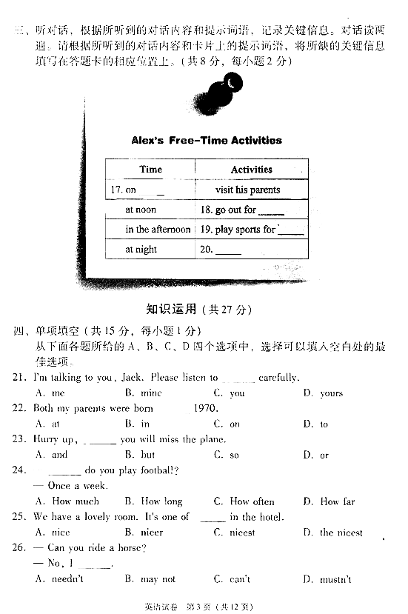

知识运用 （共27分）
四、单项填空 （共15分，每小题1分）
从下面各题所给的A、B、C、D四个选项中，选择可以填入空白处的最佳选项。
21. I’m talking to you, Jack. Please listen to _________ carefully.
A. me B. mine C. you D. yours
22. Both my parents were born ________ 1970.
A. at B. in C. on D. to
23. Hurry up, ________ you will miss the plane.
A. and B. but C. so D. or
24. –________ do you play football?
–Once a week.
A. How much B. How long C. How often D. How far
25. We have a lovely room. It’s one of _______ in the hotel.
A. nice B. nicer C. nicest D. the nicest
26. –Can you ride a horse? –No, I ________.
A. needn’t B. may not C. can’t D. mustn’t
27. I knocked on the door but ________ answered.
A. somebody B. nobody C. anybody D. everybody
28. Paul and I ________ tennis yesterday. He did much better than I.
A. play B. will play C. played D. are playing
29. Where’s Tom? His mother _________ him now.
A. is looking for B. will look for C. has looked for D. looks for
30. –Excuse me, could you tell me how ______ to Beijing Zoo? –Well, you may take Bus no. 27.
A. get B. gets C. getting D. to get
31. My aunt is a writer. She ________ more than ten books since 1980.
A. writes B. wrote C. has written D. will write
32. –What were you doing this time yesterday?
–I ______ on the grass and drawing a picture.
A. A. sit B. sat C. am sitting D. was sitting
33. I will send you an e-mail as soon as I _________ in Canada.
A. arrive B. arrived C. am arriving D. will arrive
34. Many accidents ________ by careless drivers last years.
A. are caused B. were caused C. have caused D. will cause
35. –Do you know _______ tomorrow?
–At 8 o’clock.
A. when did she come B. when she came
C. when will she come D. when she will come
五、完形填空（共12分，每小题1分）
阅读下面的短文，掌握其大意，然后从短文后各题所给的A、B、C、D四个选项中，选择最佳选项。
“I can’t believe what I’m hearing!” I thought to myself. Jeff was the last candidate (候选人)for president of Student Council. My best friend Tony came to me and said. “I’m sorry, Mike. I really thought you should be __36__.”
Later that day, I happened to pass Jeff in the dining room. I offered him a __37__ “Congratulations” and walked to my usual table. To my surprise, Jeff put his plate beside mine.
“I’m, er—I’m just wondering if you would …consider coming to work on my team,” he said__38__. “You are really smart, and you would be a great manager.”
“I don’t think so,” I replied, feeling unsure.
“Well, if you change your mind, we are meeting tomorrow,” he said before moving to another table.
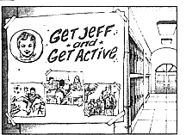
All that night, I thought about __39__ from Jeff. Maybe being a part of the election process(选举过程) would give __40__ a chance to make important changes at our school. I decided to join them.
My first goal was to __41__ a catchy advertisement. Within a few days, we designed a poster with Jeff’s pictures showing him in a number of activities. No one could walk through any hallway __42__ passing Jeff’s smiling face.
My next step was to __43__ which new activities students would like to have at our school. Many of them wanted a chess club and a volleyball team.
With the information I had collected, Jeff met with the headmaster. The headmaster __44__to add these activities to our school program.
An eighth grader said, “It’ll be like attending a new school with Jeff as president.”
Hearing these words made my heart filled with __46__. I had wanted to become president of Student Council to make a difference. I achieved that and more by working as a member of Jeff’s team. He became the most popular candidate and I was large part of his __47__. The fact that it has made a difference in other people’s lives is the real prize. What a great feeling!
36. A. heard B. chosen C. invited D. followed
37. A. polite B. loud C. warm D. cheerful
38. A. proudly B. quickly C. nervously D. regretfully
39. A. advice B. chance C. message D. offer
40. A. them B. him C. me D. us
41. A. print B. invent C. create D. send
42. A. for B. from C. with D. without
43. A. carry out B. try out C. work out D. find out
44. A. agreed B. wanted C. expected D. asked
45. A. allowed B. received C. introduced D. required
46. A. pride B. surprise C. patience D. hope
47. A. luck B. spirit C. life D. success
阅读理解（共44分）
六、阅读下列短文，根据短文内容，从短文后各题所给的A、B、C、D四个选项中，选择最佳选项。（共26分，每小题2分）
A
Susan, the US
My best friend is Fanny. She is clever and interesting. We always look after each other. The first week we met, I got sick and she looked after me every day.
Betty, England
My best friend is Ana. She is honest and serious. We were born in the same city in England. Then I moved to America with my family. I thought I would never see Ana again. When I went to college in New Your, Ana and I shared the same room!
Ken, Japan
I love to spend time with Daisuke because he is funny and smart. We enjoy talking about the funny things we did when we were children, and tell the same stupid jokes over and over again.
Lily, Australia
Linda is a very confident girl and she is really kind. Some people may wonder why Linda and I are best friends because we totally different, but I think this is why we are such good friends.
48. Who is Susan’s best friend?
A. Ana. B. Fanny. C. Linda. D. Daisuke.
49. Where is Ken from?
A. Australia. B. The US. C. England. D. Japan.
50. What is Linda like?
A. Confident and kind. B. Funny and smart.
C. Honest and serious. D. Clever and interesting.
B
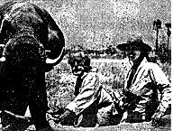
Dereck Joubert and his wife, Beverly, have made many films about wild animals in Africa. Their films and photographs are very popular and one of the photographs has been on the front cover of a National Geographic magazine.
A working day for Dereck and Beverly started very early—at 4:30 in the morning! That’s when they get up and start filming. And it’s a long day—they often work until 8:30 in the evening. In the winter it’s very cold and in the summer it can be 40C. dereck always does the filming—Beverly never does that, and she doesn’t write. But Dereck never takes photographs or records the sound. They work very well as a team, and they both believe we should shoot animals with cameras—not with guns!
When they have finished filming and taking photographs for the day, they have dinner and Dereck usually writes while Beverly looks at her photographs. At night, they usually sleep in a small tent, but they sometimes sleep in the Land Cruiser—when you’re very close to wild animals, it’s sometimes safer to sleep in the car!
Dereck and Beverly have also traveled around the world and given talks about their work. Dereck says that the animals are not just something to look at—they play an important role. Beverly thinks the wild animals can teach us a lot about ourselves.
51. Dereck and Beverly start working_________.
A. at 4:30 in the morning B. at 4:30 in the afternoon
A. at 8:30 in the morning D. at 8:30 in the evening
52. Dereck and Beverly usually sleep_________ at night.
A. in a car B. in a tent C. in a house D. in a hotel
53. Beverly thinks the wild animals __________.
A. are something to look at B. are very popular
C. play an unimportant role D. can teach us a lot
C
What do you do if you’re stranded(处于困境的) on a lonely island? Surely you need to find a way to get in touch with the outside world. Your best chance of doing this is to draw the attention a passing plane.
Body signals (信号)
Pilots from different countries understand body signals if they have the correct training. When you wave your arms up and down in a straight line, it means “yes”. When you point downwards and swing your arm from side to side, it means “no”. if you want the polite to know that it’s safe to land, push your hands out in front of you and bend (弯曲) your knees. If you want to say that it’s not safe to land, put your arms in the air and move them to one side.
Smoke signals
The smoke from a fire can be seen from far away, so it’s a good way to draw attention. If the weather is dry, it isn’t hard to start a fire. Remember, however, that fires can be very dangerous if they get out of control. Never light a fire unless you’re sure that it can’t spread. It the ground is dark, light smoke can be seen more easily. Green grass and leaves produce light smoke.
Ground-to-air signals
It’s a good idea to build some signals, too. Use large pieces of wood to make the symbols(标记). If you can’t find any wood, use earth. Some useful symbols are:
F “I need food and water.”
II “I need medicine.”
I “I am badly hurt.”
X “I am unable to move from here.
Pilots’ replies
If the pilot lowers the plane’s wings from side to side, this means “message received and understood”. (At night, the pilot flashes the plane’s green lights.) If the pilot flies the plane in a clockwise circle, this means “message received but not understood”. (At night, the pilot flashes the plane’s red lights.)
However, there is no signal which means “message not received”. Why not?
54. Which picture means “it’s not safe to land”?
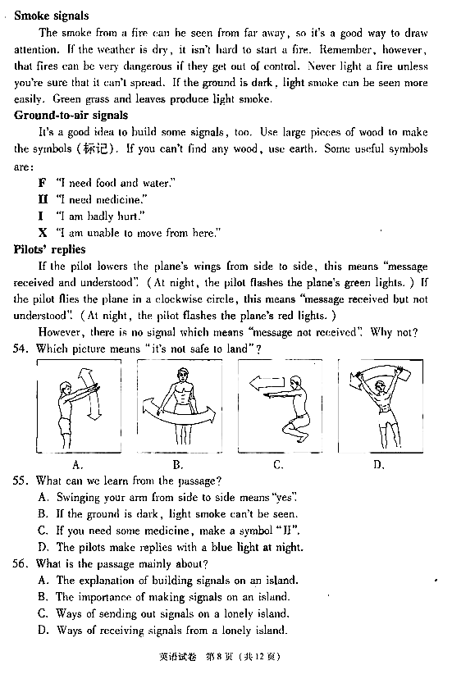

55. What can we learn from the passage?
A. Swinging your arm from side to side means “yes”.
B. If the ground is dark, light smoke can’t be seen.
C. If you need some medicine, make a symbol “II”.
D. The pilots make replies with a blue light at night.
56. What is the passage mainly about?
A. The explanation of building signals on an island.
B. The importance of making signals on an island.
C. Ways of sending out signals on a lonely island.
D. Ways of receiving signals from a lonely island.

D
My summer hols wr CWOT. B4, we used 2 go 2 NY2C my bro, his GF&thr 3 :-@ kids FTF. ILNY, its gr8.
Can you understand this sentence? If you can’t, don’t feel too bad: neither could the middle school teacher in England who received this as homework. This is Netspeak: the language of computerized communication found on Internet of cellphones. To newcomers, it can look like a completely foreign language. So, what is the “translation” of the sentence above? My summer holidays were a complete waste of time. Before, we used to go to New York to see my brother, his girlfriend, and their three screaming kids face to face. I love New York; it’s great.
Schoolteachers and parents say this new form of writing is harming(破坏) the English language. Increasing spelling and grammatical mistakes can be seen in students’ writing. They fear the language could become corrupted(面目全非的).
Everyone should just relax, say linguists(语言学家). They believe Netspeak is in fact more of a good thing. David Crystal, from the University of Wales, argues that Netspeak and Internet create a new language use and the almost lost art of diary writing has been picked up again. Geoffrey Nunberg, from Stanford University, agrees. “People get better at writing by writing,” he says. “Kids who are now doing text messaging, e-mail, and instant messages will write at least as well as, and possibly better than, their parents.
Linguist James Milroy says, for centuries, it is believed without exception that young people are harming the language. And you can bet your bottom dollar that when today’s teenagers become tomorrow’s parents, they too will thing this way. Milroy argues that languages do not and cannot become “corrupted”; they simply change to meet the new needs.
However, Netspeakers do agree that it is important to teach young people how to speak and write Standard English. Cynthia McVey says, “I can understand Netspeak worries teachers and it’s important that they get across to their pupils that text messaging is for fun, but that learning to write proper English is a must for their future.”
Perhaps we should give teenagers a little more trust anyway. Erin, age 12, says, “I wouldn’t use text language in my homework. Texting is just for fun.”
57. What is the main purpose of the first paragraph?
A. To give an example of a foreign language.
B. To show an example of creative methods.
C. To express worries about using Netspeak.
D. To lead in the topic of Netspeak.
58. Which of the following is true according to the passage?
A. Cynthia McVey points out teenagers can deal with Netspeak properly.
B. Geoffrey Nunberg believes Netspeakers can write Standard English.
C. David Crystal things Netspeak helps develop the habit of writing.
D. James Milroy says that language is changing and improving.
59. The expression “bet your bottom dollar” in Paragraph 5 means __________.
A. Be fairly sure B. be greatly surprised
C. think it a pity D. find it interesting
60. What can be the best title fro the passage?
A. Netspeak: A Widely-Used Language on Internet
B. Is Netspeak Harming the English Language?
C. Is Netspeak Helpful in the English Language?
D. Netspeak: Advantages and Disadvantages

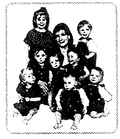
七、阅读短文，根据短文内容，从短文后的五个选项中选出能填入空白处的最佳选项。选项中有一项为多余选项。（共8分，每小题2分）
Kenny and Bobbi McCaughey live in lowa. They have a big family. Mikayla is the oldest child in the family. She is six years old. The other children are Brandon, Joel, Kelsay, Kenny, Natalie, Alexis and Nathan. They are all five years old. Why are they all the same age? 61 . They are septuplets!
It is hard work to look after seven babies at the same time. 62 . In the beginning, many people helped them. They helped to feed, clean, and dress the babies. Every week, the septuplets used about 170 diapers(尿布)? 63 .
Now the children are older. The septuplets started school this year. But they go to school at home, like their big sister, Mikayla. When Mikayla was ready for school, Kenny and Bobbi decided to teach her at home. 64 . Now Bobbi is the teacher for all eight of her children.
- They drank a lot of milk, too.
- Because they were born together.
- Last year, Bobbi was Mikayla’s teacher.
- Kenny and Bobbi are interested in cooking.
- But Kenny and Bobbi didn’t look after them alone.

八、阅读短文，根据短文内容回答问题。（共10分，每小题2分）

We need to be responsible for our environment. Being a frugal consumer(节俭的消费者) is one way to help. But, what exactly does that mean?
Use It Up
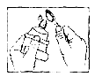
You can use things up instead of wasting them. Squeeze that last bit of toothpaste out of the rube. Use the last little piece of soap. Don’t throw away any bits of the biscuit at the bottom of the box.
Wear It Out
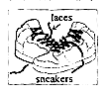
You do not always need to have new things. Suppose your sneakers have broken laces, but they still fit you. Repair them and wear them longer. You don’t have to have the latest iPhone until the old one doesn’t work any more. Then you can get a new one. Think twice before replacing something that still works.
Make It Do
When something you want is not on hand, look for something else that you already have to take its place. Suppose you are packing your lunch for tomorrow and want a butter sandwich. You are out of butter. Have a cheese sandwich instead so that you can use all of the cheese. Learn to fix broken boys instead of just throwing them away. With a little thought, you can make something do, instead of buying something new.
Do Without
Think about all those things that you would like to have. Do you really need them? How long will you really play with that new toy you saw on TV? Making the things that we want uses up our world’s resources(资源). And, getting rid of the things we don’t want any more takes up even more resources and space.
65. Do we need to be responsible for our environment?
66. How do we deal with the last little piece of soap?
67. When do we need to get a new iPhone?
68. What should we do when something we want is not on hand?
69. What does the writer want to tell us?
书面表达 （25分）
- 完成句子 （共10分，每小题2分）
根据中文意思完成句子。
70. 我喜欢北京的秋天,你呢?
I like the autumn in Beijing. ____________ you?
71. 多吃蔬菜水果对健康有好处。
____________ you health to eat more vegetables and fruit
72. 你愿意参观我们的新学校吗？
____________ to visit our new school?
73. 哥哥花了一个星期教我弹吉它。
_____________ to play the guitar.
74.妈妈常常告诉我，既不要炫耀自己，也不要轻视别人。
Mom often ____________________.

十、文段表达（共15分）
根据中文和英文提示，写一篇意思连贯、符合逻辑、不少于60词的回信。 信的开头和结尾已给出，其词数不计入所完成的回信。请不要写出你的校名和姓名。
75. 成长中的每个人都要面对烦恼，滨解决问题。假设你叫刘明。是美国中学生艾丽丝的朋友。你收到了她的电子邮件，请给她回复，回答她的问题，提出你的建议，并就此事谈谈你的看法。
