2010年东营市初中学生学业考试
英 语 试 题
(总分120分 考试时间 120分钟)
注意事项：
1、本试题分第Ⅰ卷和第Ⅱ卷两部分。第Ⅰ卷8页为选择题，65分；第Ⅱ卷4页为非选择题，55分；共120分。
2、答第Ⅰ卷前务必将自己的姓名、考号、考试科目涂写在答题卡上。考试结束，试题和答题卡一并收回。
3、第Ⅰ卷每题选出答案后，都必须用2B铅笔把答题卡上对应题目的答案标号（ABCD）涂黑。如需改动，必须先用橡皮擦干净，再改涂其它答案。
4、听力填表题为第Ⅱ卷的第四大题，在试卷第9页上。
第Ⅰ卷 （选择题， 共65分）
一、听力选择（共15小题，计15分；每小题约有8秒钟的答题时间）
(一) 录音中有五个句子，每个句子听一遍，然后从每小题A、B、C中选出能对每个句子做出适当反应的答语。
1. A. Yes, please. B. I’ll get it. C. No, I don’t.
2. A. The weather is nice. B. Very well, thanks. C. Yes, I did.
3. A. So I did. B. What a pity. C. It doesn’t matter.
4. A. All right. B. Nothing special. C. I am glad you like it.
5. A. It’s expensive. B. How about this one?
C. Sure, what size do you need?
（二）录音中有五组对话，听对话两遍后，从每小题A、B、C中选出能回答所给问题的正确答案。
6. What kind of movie does the man like best?
A. Thrillers. B. Documentaries. C. Action movies.
7. How often does the woman go to the training center now?
A. Twice a week. B. Once a week. C. Every day.
8. How many toys are there in all(总共)?
A. One. B. Two. C. Three.
9. What does the boy want to be in the future?
A. A pilot. B. A teacher. C. An engineer.
10. How’s the weather tomorrow?
A. Sunny. B. Cloudy. C. Rainy.
（三）录音中有一段对话，听对话两遍后，从每小题A、B、C中选出能回答所给问题的正确答案。（录音播放前你有40秒钟的读题时间）
11. What does the woman want to talk about with the coach?
A. About the game. B. About coaching. C. About football.
12. How long did the coach play professional football?
A. For 2 years. B. For 10 years. C. For 10 months.
13. How did he break his leg?
A. In a football match. B. In a traffic accident. C. Falling out of a tree.
14. What did he want to do?
A. To coach professional football.
B. To coach university football.
C. To coach high school football.
15. Why is he coaching university men now?
A. Because he wants to play with young men.
B. Because the university wanted him and asked him.
C. Because he doesn’t want to work with young women.

（注意：请同学们翻到第9页第Ⅱ卷第四大题，继续做听力填表题。）
二、单项选择 （共20小题，计20分）
从每小题A、B、C、D中选出一个能填入句中空白处的最佳答案。
16. Samaranch, who is old friend of Chinese people, died on April 21, 2010.
A. a B. an C. the D. /
17. Whenever you meet with difficulties, you can ask the policeman ____help.
A. at B. in C. for D. with
18. Don’t just wait for other’s help. God help those who help .
A. him B. you C. them D. themselves
19. Put the milk in the fridge, it will go bad easily.
A. or B. so C. but D. and
20. It’s hot. Let’s have some .
A. wine B. porridge C. ice cream D. strawberries
21. The 2010 Guangzhou Asian Games will be ________ from Nov. 12 to Nov. 27.
A. held B. examined C. achieved D. expected
22. Zhang Yimou is not in China. He has gone .
A. away B. back C. abroad D. around
23. – Tell me about Brother Sharp, please.
-- He was a beggar(乞丐). He became a blue-eyed boy(红人) on the Internet because of his cool appearance and dressing style.
A. nothing B. anything C. something D. everything
24. –How far is it from the railway station to the hotel?
--It’s about _______ walk.
A. ten minute’s B. ten –minutes C. ten minutes’ D. ten minutes
25. --Can you tell me to live a low-carbon(低碳) life?
-- OK. Use both sides of the paper. Don’t use plastic bags or disposable goods(一次性用品).
A. how B. why C. when D. where
26. It is impolite to leave the meeting finishes.
A. after B. before C. until D. while
27. – Are you “planting online vegetables”?
-- No. I think it’s a waste of time.
A. major in B. afraid of C. angry with D. interested in
28. You should praise your son. ________, he works harder than before.
A. After all B. Above all C. As a result D. First of all
29. I don’t like Xiao Shenyang’s performances ________ many people like them.
A. as if B. as for C. so that D. even though
30. People complain that the price of the apartment is getting .
A. lower and lower B. higher and higher
C. cheaper and cheaper D. more and more expensive
31. After so many years’ hard work, Zhao Hongbo and Shen Xue’s dream in 2010 Vancouver Winter Olympic Games.
A. came true B. gave up C. built up D. worked out
32. Whether you can enter the high school yourself.
A. calls for B. depends on C. agrees with D. connects with
33. I am a fan of Liu Qian. _____ his magic ________ his humor attracts me.
A. Both… and B. Either…or C. Neither…nor D. Not only… but also
34. “I’ll pay him as soon as he the TV set to my home.” said the man.
A. sends B. sent C. is sending D. will send
35. He to Dongying many times, so he knows every corner of it.
A. went B. will go C. has gone D. has been
三、阅读理解（共20小题，计30分）
阅读下列短文，然后从每小题A、B、C、D四个选项中选出能回答所提问题或完成所给句子的最佳答案。

A
We Are One--'Expo Through My Eyes'
Sharing increases your happiness. To celebrate the 2010 Shanghai World Expo, China Daily invites you to share what you’ve seen, heard and experienced at the 6-month international event or Expo-related stories in ENGLISH. Whether you are an Expo volunteer, a journalist, or a tourist, we’d like you to share with us your expo experience, as viewed through your eyes. So if you like, please join us today in sharing the joy!
Eligibility(适宜人选): Everyone
Topic: 2010 Shanghai World Expo
Language: ENGLISH Only
Length: No more than 1,000 words
Content: Stories accompanied(附有) by photos are encouraged.
Duration: May 1, 2010--October 31, 2010
How to submit your stories: Send your stories and photos to expo@chinadaily.com.cn
Why join us: In addition to(除……之外) the satisfaction of supporting our work.
- Your stories will come out on China Daily’s website;
- You will go in a lucky draw to win a prize.
36. China Daily invites us .
A. to celebrate the 2010 Shanghai World Expo B. to support their work
C. to write Expo-related stories in English for them D. to win a prize
37. Who can take part in this activity?
A. Everybody. B. A tourist. C. A journalist. D. An Expo volunteer.
38. What does the underlined word “submit” mean?
A. 撰稿 B. 呈交 C. 发表 D. 发送
39. Your story must not .
A. be written in English B. have any pictures
C. be less than 1000 words D. be submitted after October 31, 2010.
40. If your story is chosen by the editor, we can read it .
A. in a magazine B. in a storybook
C. on China Daily’s website D. in the newspaper named China Daily
B

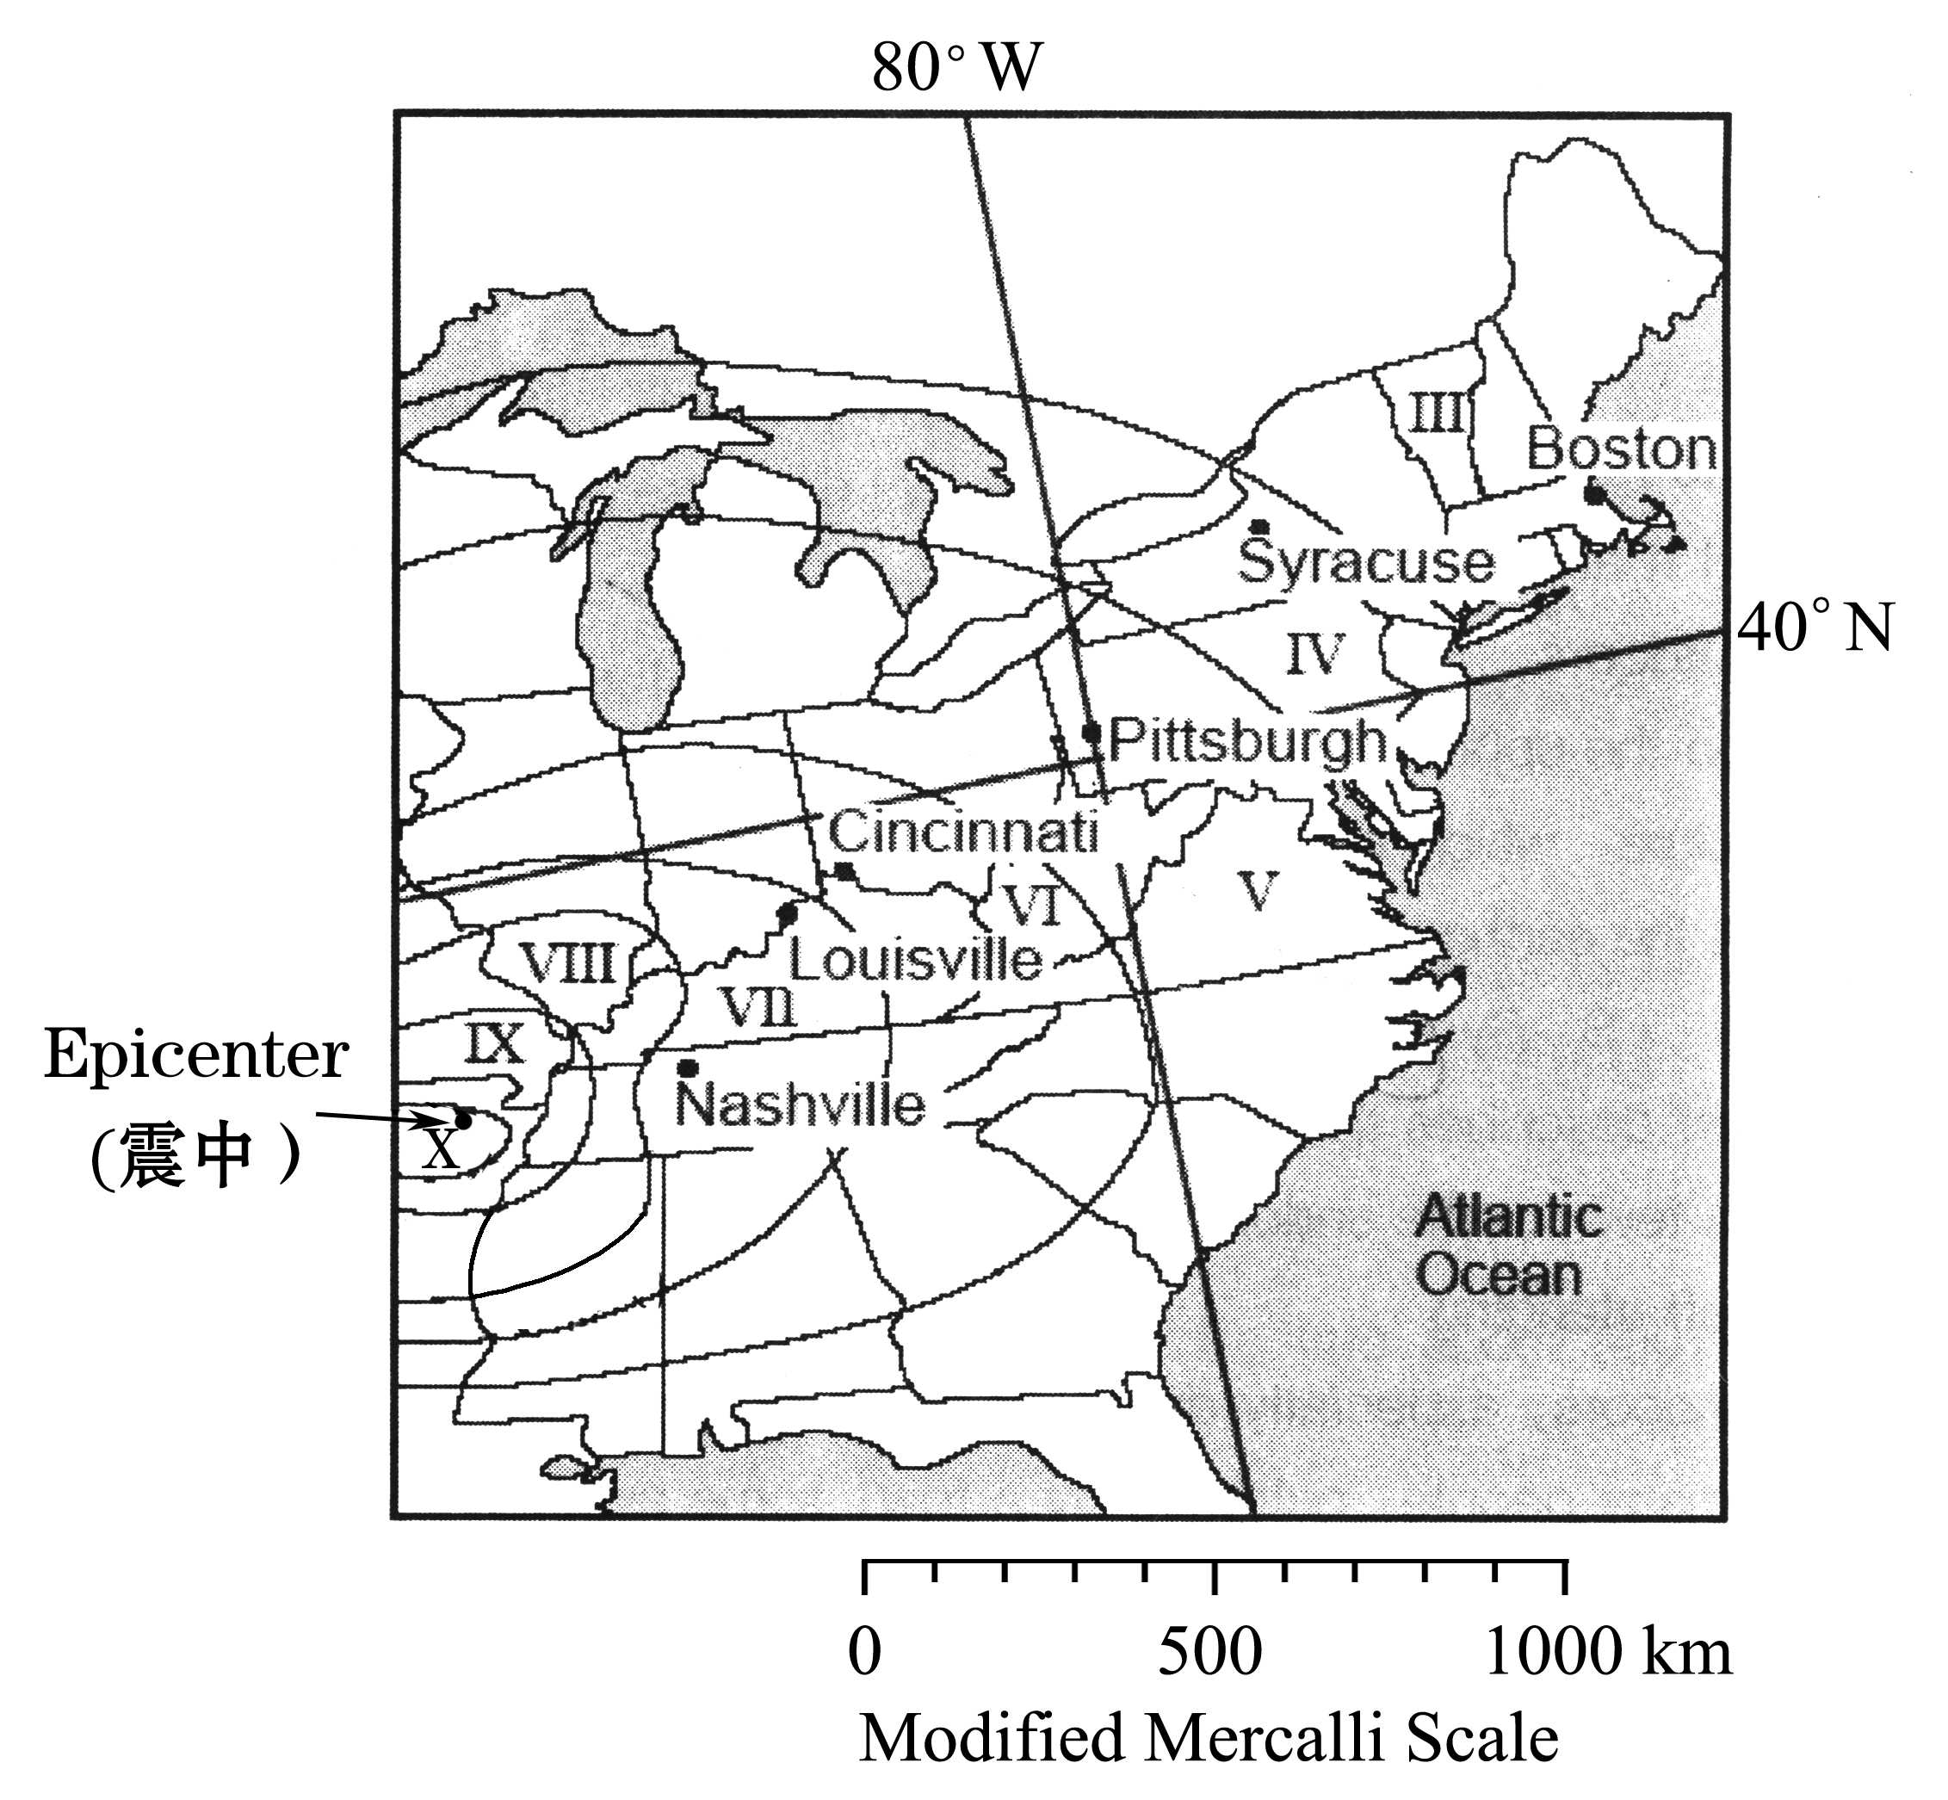
Earthquake Intensity & Observed Effects（强度与现象）
I. Felt by only a few people under very special conditions.
II. Felt by only a few people at rest, especially on the upper floors of buildings.
III. Felt noticeably indoors, especially on upper floors of buildings.
IV. Felt indoors by many people, outdoors by a few; some awaked.
V. Felt by nearly everyone; many awaked; dishes and windows break; plaster (灰泥) cracks (开裂).
VI. Felt by everyone; many frightened and run outdoors; heavy furniture such as tables and shelves moves.
VII. Everyone runs outdoors; small to moderate (中等的) damage(损毁) in usual buildings.
VIII. Considerable (相当大的) damage in usual buildings; monuments(碑) fall.
IX. Considerable damage in all buildings; ground cracks; underground pipes (管道) break.
X. Most buildings damaged; rails bend(弯曲); landslides (山崩) take place; water splashes(溅落) over banks.
XI. Few buildings left standing; bridges damaged; wide cracks in the ground; underground pipes break.
XII. Damage total; waves seen on ground; objects thrown into air.
41. According to the picture, what is the possible position of the earthquake’s epicenter?
A. 36°N, 90°W. B. 36°N, 90°E . C. 90°N, 36°W. D. 90°N, 36°E.
42. What is the effects of earthquake intensity IV?
A. Everyone runs outdoors.
B. Only a few people feel it.
C. Many people who stay indoors feel it.
D. Felt by people on the upper floors of buildings.
43. According to the picture, which city would have announced the report: “Nearly everyone felt the earthquake, and many people were awaked. Dishes and windows were broken”?
A. Cincinnati. B. Louisville. C. Pittsburgh. D. Nashville.
44. Which statement best describes the earthquake intensity at Boston?
A. Felt indoors by few people under very special conditions.
B. Few buildings left standing.
C. Felt noticeably indoors, especially on upper floors of buildings.
D. Felt indoors by many people, outdoors by a few, some awaked.
45. For which city was the description of an earthquake “Heavy furniture moved, everyone
felt it, and many were frightened and ran outdoors” reported?
A. Nashville. B. Louisville. C. Syracuse. D. Cincinnati.

C
Passage 1 Mobile Phone Madness
How much do you love your mobile phone? A Chinese student had to call 110 for help this week after he got his arm stuck in a toilet trying to rescue(援救) his mobile phone. After dropping his phone in the toilet, he decided to wrap(包，裹) his arm in newspaper in the hopes of keeping clean. But the newspapers became larger in size in the water, and then even his roommates couldn't help him pull his arm out. So policemen were called and they spent an hour unsticking the stuck student.
Passage 2 Crazy Pet Lovers
How much do you love your pets? Many people in China are famous for how much they love their pets. They dress them up in fashionable clothing and buy them high quality food. But would they spend 7,000 English pounds (68,000 yuan) on a wedding(婚礼) for their pets? And that's what a couple in Brazil spent on a fancy wedding for their pet Yorkshire terriers( a kind of dog).
Passage 3 Oh, rats!
When something goes wrong, you can often hear Westerners cry “Oh, rats”. But when it comes to Southern China, “Oh, rats!” can mean it's what you want for dinner. According to a report in China Daily, some restaurants in Guangzhou serve rat meat. But, actually, most of those rats are field mice. What would Mickey Mouse say?
Passage 4 Liar(说谎者), liar
Here's some news that most women already know. Men tell more lies than women. The London Daily Mail cites(引用) a new study that says men tell about three lies a day, while women tell only two lies a day. Men are also less likely to feel guilty about lying, according to this week's survey of 3,000 people by a research organization called One Poll. According to the Poll, lying to our mothers is very popular. But then, so is lying at work. And both men and women will lie when it comes to how much they've drunk. So how easy is it to tell when someone is lying?
46. Put the statements into the right order according to passage 1.
① They called policemen for help.
② He dropped his mobile phone in the toilet.
③ His roommates tried to help him pull his arm out, but failed.
④ The newspapers expanded(膨胀) in the water, so he got his arm stuck.
⑤ He wrapped his arm in newspaper before trying to take out his phone from the toilet.
A. ②⑤④③① B. ②④③⑤① C. ①⑤④②③ D. ①②⑤④③
47. Why does the writer call the Brazilian couple “crazy pet lovers”?
A. They dress their pets up in fashionable clothing.
B. They buy their pets high quality food.
C. They spent ￥68,000 on a wedding for their pets.
D. They spent ￡7,000 in buying a pet.
48. If you say “oh, rats” in Guangzhou, it can mean that .
A. something goes wrong B. you see some field mice
C. you are a Mickey Mouse lover D. you’d like to have rat meat for dinner
49. According to the new study on lying, which of the following is not true?
A. Women tell less lies than men.
B. Women are more likely to feel guilty about lying.
C. Lying at work is more popular than lying to our mothers.
D. Neither men nor women want to tell the truth about how much they have drunk.
50. What is NOT mentioned?
A. It is difficult to unstick the stuck student.
B. The couple’s pets are Yorkshire terriers.
C. People in China enjoy eating rat meat.
D. 3,000 people took part in the survey made by One Poll.

D
One day, I went to see my last patient(病人), an old woman. In the doorway, I saw she was struggling (挣扎) to put socks on her swollen (浮肿)feet in the bed. I stepped in, spoke quickly to the nurse, read her chart noting. I was almost in the clear that she was not in serious condition.
I asked, “Could I help put on your socks? How are you feeling? Your sugars and blood pressure were high but they're better today. The nurse mentioned you're anxious to see your son. He's visiting you today. It's nice to have a family visit. I think you really look forward to seeing him."
"Sit down, doctor. This is my story, not yours." She said with a serious voice.
I was surprised as I helped her with the socks. She told me that her only son lived around the corner from her, but she had not seen him in five years. She believed that was the main cause of her health problems. After hearing her story and putting on her socks, I asked if there was anything else I could do for her. She shook her head no and smiled. All she wanted me to do was to listen.
Each story is different. Some are detailed; others are simple. Some have a beginning, middle and end; others don’t have clear ends. Some are true; others not. Yet all those things do not really matter. What matters to the storyteller is that the story is heard — without interruption(打断) or judgment(评价).
It was that woman who taught me the importance of stopping, sitting down and truly listening. And, not long after, in an unexpected accident, I became a patient. 20 years later, I sit all the time — in a wheelchair.
For as long as I could, I continued to see patients from my chair. I believe in the power of listening.
51. How was the old woman?
A. Her feet were swollen. B. Her sugars were high.
C. She was not badly ill. D. Her blood pressure was better.
52. How did the doctor know that the old woman’s son was visiting her?
A. The nurse told him. B. The old woman told him.
C. The woman’s son told him. D. The doctor got it from her chart noting.
53. What did the old woman think caused her health problems?
A. Her son’s not seeing her. B. No one listening to her story.
C. The medical care of the hospital. D. The distance between her and her son.
54. When the patient told the doctor her stories, what she needed might be ________.
A. keeping smiling B. interruption or judgment
C. listening without interruption D. communicating with each other
55. Which statement is NOT right according to the passage?
A. Her son lived close to her house.
B. The old woman didn’t need the doctor’s treatments.
C. Listening is powerful medicine.
D. The doctor has to “walk” with the help of a wheel chair.

试卷类型 A
2010年东营市初中学生学业考试
英 语 试 题
第Ⅱ卷 （非选择题， 共55分）
注意事项：
1、第Ⅱ卷共4页，用钢笔或圆珠笔直接答在试卷上。
2、答卷前将密封线内的项目填写清楚。
题 号 | 四 | 五 | 六 | 七 | 八 | 总 分
分 数

四、听力填表（共5小题，计5分）
得 分 | 评卷人
本录音是对世博园部分场馆的简单介绍。听录音两遍后，根据所听内容完成下面的表格(每空不多于三个词)。（录音播放前你有40秒钟的读题时间）
The Shanghai Expo Park(世博园) is 5.28k㎡. There are about 170 pavilions(馆) in the park.
The China Pavilion | It is the（56） pavilion. It has 3 parts.
The UK Pavilion | British people put 60,000 seeds in it to show their（57） .
The Japan Pavilion | We can see the latest （58） in it.
The Belgium(比利时) Pavilion | You can see moving pictures about（59） of Belgium. Visitors can get free chocolate there.
The Russian Pavilion | You can find a spaceship there. We can see the（60） of the future.
得 分 | 评卷人
五、动词填空（共10空，计10分）
阅读下面短文，用括号内所给动词的适当形式填空 (必要时可加情态动词或助动词)。
Henry found a job in a bookstore after he finished middle school. He wouldn't do anything but wanted to get rich.
It was a cold morning. It (61)_______ (snow) and there was thin ice on the streets. Few people went to buy the books and the young man had nothing (62) ______ (do). He hated to read, so he watched the traffic. Suddenly he (63) ______ (see) a bag fall off a truck and it landed by the other side of the street.
"It (64)_____ (be) full of expensive things." Henry said to himself. "I have to get it right now, or others (65) ______ (take) it away."
He went out of the shop and ran across the street. A driver saw him and began to whistle (鸣笛), but he didn't hear it and went on (66) ______(run). The man drove to the side, hit a big tree and (67) ______ (hurt) in the accident. Two weeks later Henry was taken to court. A judge asked if he heard the whistle when he was running across the street. He said that something was wrong with his ears and he could hear nothing.
"But you (68) ______ (hear) me this time," said the judge.
"Oh, I'm sorry. Now I can hear with one ear."
"(69) ______(cover) the ear with your hand and listen to me with your deaf one. Well, can you hear me?"
"No, I can't, sir."
“You (70) ______ (tell) lies. There is nothing wrong with either of your ears.” The judge said.
得 分 | 评卷人
六、综合填空（共10空，计10分）
阅读短文，根据短文内容及首字母提示，在空白处填入一个适当的单词。
Ron, the teacher at the skydiving(跳伞运动) school, was surprised when the gray-haired man said that his name was Walter and asked if he could take skydiving lessons. Ron asked him how old he was and he (71) r that he was 60. Ron explained to Walter that (72) a over 50 had to be checked by a doctor before he could learn to jump from a plane. “I’m sorry, but I can’t let you start learning (73) w a letter from your doctor.”
Walter smiled. “Here is a letter from my doctor. He asked me to take (74) l of tests and he says that I’m fine.”
So Walter was able to join the skydiving school. He came to all the lessons and worked very (75) h . Soon it was the time for him to make his (76) f jump. Ron asked him if he was feeling OK. Walter answered that he had never felt better. However, he added that there was something he should have told Ron (77) e . Ron asked what it was and Walter smiled. Then just before he jumped, he told Ron that he wasn’t 60. Ron asked how old Walter (78) r was and Walter told him he was 75!
Walter has a lot of (79) h . He enjoys riding fast motorbikes and (80)
c mountains. Last year he was saved by a police helicopter(直升飞机) in Wales.
His daughter Betty worries about him. “I think he should stop all these activities. But my mother says that as long as he’s happy, it’s OK.”
七、阅读表达 (共5小题，计10分)
得 分 | 评卷人
阅读短文，根据要求完成下面各小题。

83If the only sports you do are dancing your fingers across your keyboard, you could be in serious danger of more than just becoming fat!
Do you feel sleepy, like something is weighing down on your head? Do you feel forgetful? Do you sometimes feel uncomfortable up and down your neck and lower back, and you can’t explain why? Do you get sick often? It could be radiation(辐射) from your computer causing it. If you spend three hours or more a day in front of a computer, (and at this point, who doesn’t?) you are more easily harmed by these hazards(危害).
84 We have got so used to using computers that we don’t often think of them as dangerous sources(来源) of harmful(有害的) radiation. A safe amount radiation is 25 V/m(Volts/meter). Do you want to guess how much our personal computers give off?
★ Keyboard: 1000 V/m ★Mouse: 450V/m ★Monitor: 218 V/m
★CPU: 170V/m ★Notebook computers: 2,500 V/m
Ways to Protect Yourself from Harmful Computer Radiation:
1. Decorate your desk with cactus(仙人掌) plants, they take in radiation.
2. Drink two to three cups of green tea a day and eat an orange daily. The vitamins in tea leaves and oranges protect us from radiation and keep our eyes healthy as well.
3. Use a screen filter(过滤器) for your monitor.
4. Avoid having metal objects nearby on your desk.
5. Put the back of the computer to the wall. Most of the radiation comes off the back.
6. Keep your monitor at least 50cm away from your face.
7. Keep your computer rooms ventilated(空气流通的).
8. Eat healthily—especially fruits and vegetables.
9. Don’t fall asleep on your computer. Turn it off if you have to rest nearby.
The ways above are useful, why not have a try at once?
A. 根据短文内容简要回答问题。
81. Which is safer, using a desk computer or a notebook computer?
__________________________________________________________________________
82. Which of the nine ways mentions diets?
__________________________________________________________________________
B．将短文中划线的句子译成汉语。
83.__________________________________________________________________________
84. _________________________________________________________________________
- 请给短文选一个适当的英文标题。
85. Which is the best title of this passage? ___________
A. Harmful radiation B. Computer problems
C. Protect yourself from computers D. Computer radiation: a silent killer
得 分 | 评卷人
八、书面表达（共１题，计20分）

Emily将她的烦恼写在了博客上并征求大家的建议。请了解她的烦恼并写出你（Chen Lin—from Dongying）的建议，要求字数在100词左右，建议的开头和结尾已经给出，不计入总字数。
建议应包括：（1）孩子应尊重父母（2）父母经验丰富（3）父母的要求是对你的成长有好处的（4）…… （5）多同父母交流沟通。
Possible new words: respect v & n. 尊重; responsible adj. 有责任感的;
demand v. & n. 要求
Here are Emily’s problems on the Blog:
My problem is my parents. They never stop going on about(唠叨) how I should keep my room clean, keep my hair tidy and wear smart clothes. They even make me do the washing-up after dinner every night! None of my friends have got such terrible parents. What should I do?
Emily，USA
Hi, Emily. I think it’s lucky for you to have such good parents.
________________________________________________________________________________________________________________________________________________________________________________________________________________________________________________________________________________________________________________________________________________________________________________________________________________________________________________________________________________________________________________________________________________________________________________________________________________________________
________________________________________________________________________________________________________________________________________________________
Chen Lin, Dongying



