2010年四川眉山市初中毕业会考试题英语
本试卷分第Ⅰ卷(选择题)和第Ⅱ卷(非选择题)两部分。第Ⅰ卷第1至8页，第Ⅱ卷第9至12页。共120分，考试时间120分钟。
考试结束后，将第Ⅱ卷和答题卡按规定装袋上交。
第Ⅰ卷（三部分，共100分）
注意事项：
- 答第Ⅰ卷前，考生务必将自己的姓名、准考证号、考试科目涂写在答题卡上。
- 每小题选出答案后，用铅笔把答题卡上对应题目的答案标号涂黑。如需改动，用橡皮擦干净后，再选涂其它答案，不能答在试卷上。
- 考试结束后，本试卷由考场统一收回集中，管理不上交。
第一部分：听力（共三节，满分20分）
第一节：（共5个句子；每小题1分，满分5分）
下面你将听到5个句子，根据每个句子的内容，从每组图片的A、B、C三个选项中选出相应的图片。听完每个句子后，你将有10秒钟的时间来回答有关小题和阅读下一小题。每个句子读两遍。

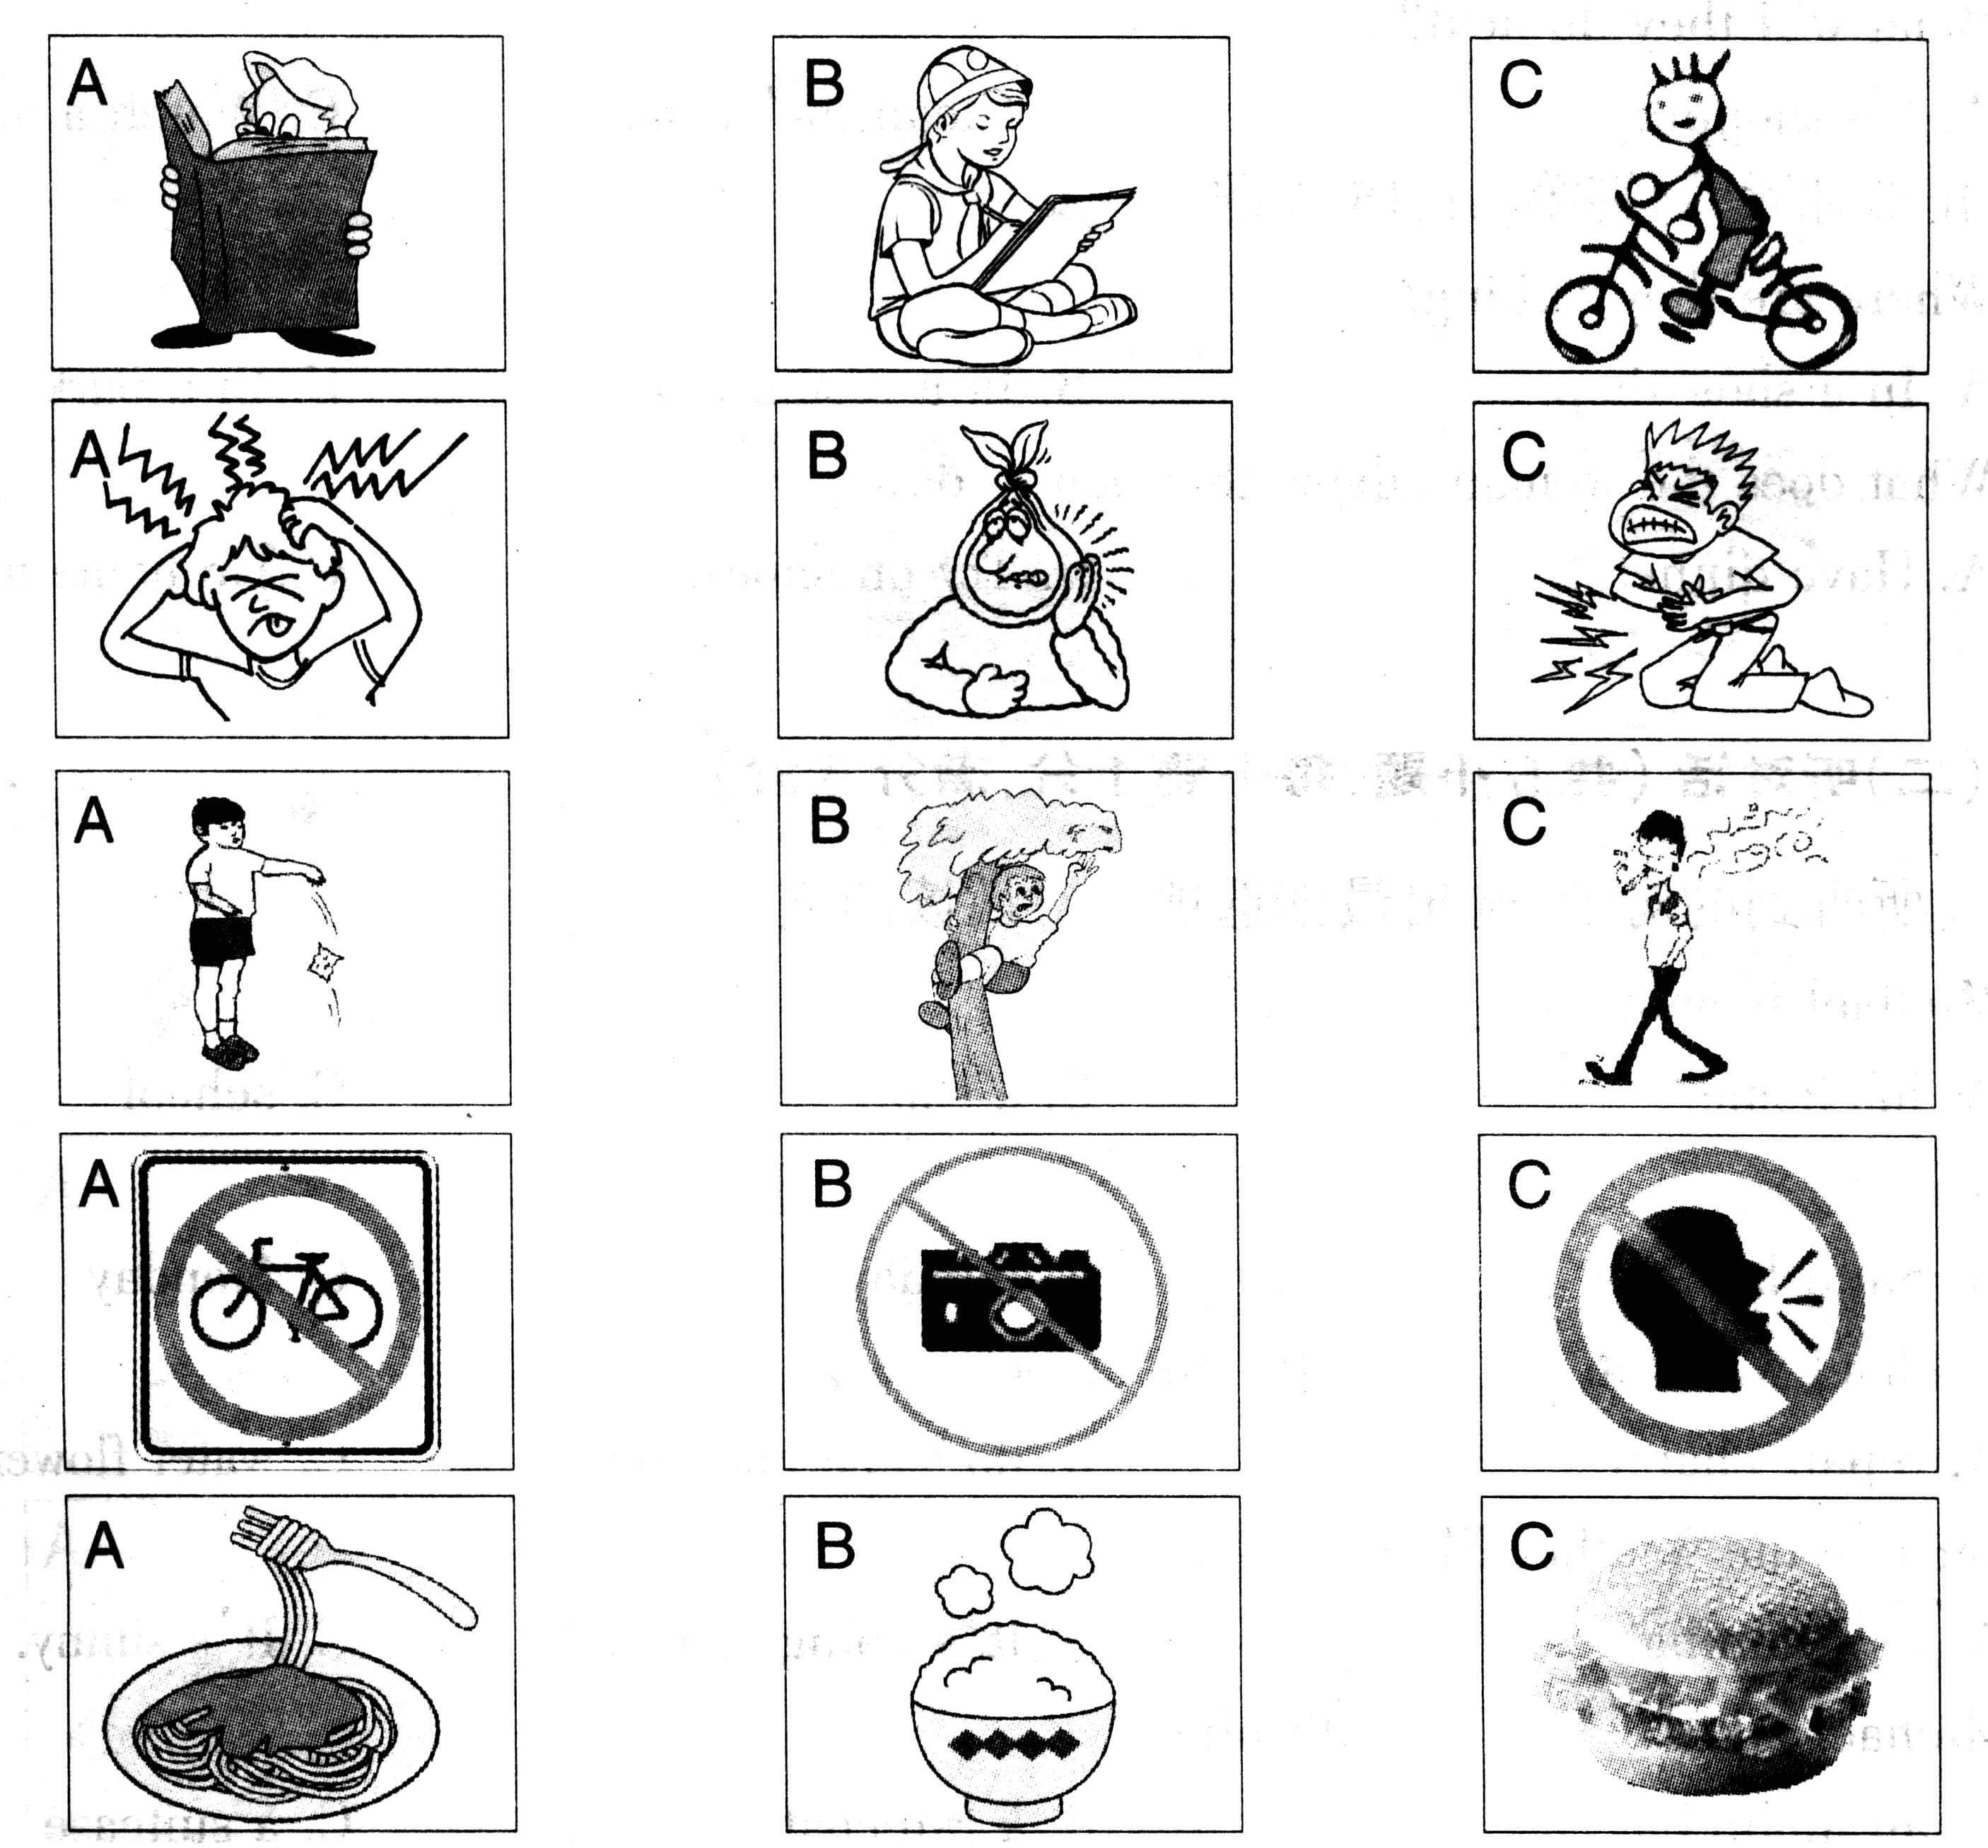
1

2

3

4

5
第二节：（共10个小题；每小题1分，满分10分）
下面你将听到几段对话，每段对话后有几个小题，从题中所给的A、B、C三个选项中选出最佳选项。听每段对话前你将有时间阅读各个小题，每小题5秒钟；听完后，各小题将给出5秒钟的作答时间。每段对话读三遍。
听第一段对话，回答第6、7小题。
6. What does the man want to do?
A. Play football. B. Join an English club. C. Write an e-mail.
7. What does the man need to do then?
A. Fill in a form. B. Speak English. C. Write a diary.
听第二段对话，回答第8、9小题。
8. What does the boy want to send Betty for her birthday?
A. Some cards. B. A big cake. C. Some flowers.
9. What does the girl want to buy for Betty?
A. A birthday cake. B. Some drinks. C. School things.
听第三段对话，回答第10、11小题。
10. What is Tony’s father?
A. A doctor. B. An engineer. C. A teacher.
11. Where is Toy’s father’s factory?
A. In a big city. B. In a village. C. Near a town.
听第四段对话，回答第12、13小题。
12. How long has the man been away?
A. For two weeks. B. For two months. C. For two years.
13. What will they do next?
A. Go shopping. B. Clean the room. C. Watch a movie.
听第五段对话，回答第14、15小题。
14. Where are they talking?
A. In a shoe shop. B. In a restaurant. C. In a park.
15. What does the woman advise the man to do ?
A. Have dinner. B. Try on shoes. C. Go home together.
第三节：（共5小题；每小题1分，满分5分）
下面你将听到一段独白，请根据你所听到的内容，用适当的单词补全下面五个句子，每空一词。独白读三遍。
16. uses sign language according to the passage.
17. Sign language is not , so we can learn it easily.
18. If someone at you, it means he/she is friendly to you.
19. If you can a question, you should put up your hand first in class.
20. When you put your finger in front of your , you mean “Be quiet.”
第二部分：英语知识运用（共2节，满分25分）
第一节：单项填空（共15小题；每小题1分，满分15分）
从A、B、C、D四个选项中，选出可以填入空白处的最佳选项，并在答题卡上将该项涂黑。
21. －My brother and I will go to the library tomorrow.
－______. Shall we go together?
A. So am I B. So do I C. So I am D. So will I
22. --- Do you know the boy________ is sitting next to Peter?
--- Yes. He is Peter’s friend. They are celebrating his ________ birthday.
A. who; ninth B. that; nineth C. /; nineth D. which; ninth
23. --- You can use MSN to talk with Vivien on the Internet.
--- I know. But can you tell me ________?
A. when I can use it B. what I can use it
C. why can I use it D. how can I use it
24. --- What do you think of the lecture of Li Yang’s Crazy English?
--- I think it’s _______ , but someone thinks it’s much too ________.
A. wonderful enough; bored B. enough wonderful; boring
C. wonderful enough; boring D. enough wonderful; bored
25. --- It’s difficult for the village children to cross the river for school.
--- I think a bridge ________ over the river.
A. should be built B. is being built C. has been built D. was built
26. --- Zhao Rui, it’s said that many famous singers will come to Yangzhou on April 18th.
How about watching the evening show there?
--- ________! Let’s ask Huang Tao to go with us.
A. Best wishes B. Sounds great C. Good luck D. That’s OK
27 .--Which of these two sweaters will you take?
--I’ll take . They look nearly the same, and I just need one.
A. both B. either C. none D. all
28. — David promised to come round to have supper with us today.
— But he ____. I’ve been alone for half an hour.
A. won’t B. hadn’t C. hasn’t D. doesn’t
29. —Would you like some drinks, boys?
—Yes, ____ , please.
A. some oranges B. two boxes of chocolate
C. some cakes D. two boxes of cola
30. -- Lily is coming by plane tomorrow.
-- Let’s go to airport to meet her.
A. a; a B. /; a C. the; the D. /; the
31. I feel it hard to keep up with my classmates in study and sometimes I lose heart. But whenever I want to , my teacher always encourages me to work harder.
A. go on B. run away C. give up D. look out
32. -- Can I tell Peter about the news?
-- No, I don’t want anyone else to know it. You keep it to yourself.
A. must B. need C. can D. may
33. Just before the Chinese class, I suddenly realized that I forgot _______ my Chinese text book.
A. bring B. bringing C. and bring D. to bring
34. There are so many kinds of Mp3 in the shop. We can’t decide .
A. what to buy B. to buy what C. which to buy D. to buy which
35. ---- If you have any trouble, be sure to call me.
---- _______.
A. I am sorry to hear that B. I will. Thank you very much
C. I have no trouble D. I will think it over
第二节：完形填空（共10小题；每小题1分, 满分10分）
阅读下列短文，掌握其大意，然后从36~45各题所给的四个选项中，选出最佳选项，并在答题卡上将该项涂黑。
China is the home of tea, 36 has more than 4,000 years of history. People in China drink tea daily. 37 the three major drinks ----tea, coffee and cocoa, tea is drunk by 38 people in the world. Tea from China, along 39 silk and porcelain, began to be known by the world over a thousand years ago and has been an important Chinese export 40 .
Tea leaves 41 mainly in the area south of the Yangtze River, in the provinces of Zhejiang, Jiangxi and Fujian, because of the mild 42 and rich soil there. Longjing, Wulong, Pu’er and Tieguanyin are all 43 kinds of tea.
Over the past centuries, Chinese people 44 their unique tea culture, which includes tea planting, tea-leaf picking, tea making, tea drinking and so on. Tea is 45 a popular topic which is often mentioned in dances, songs, poems and novels.
36. A. who B. which C. where D. when
37. A. In B. For C. Of D. By
38. A. the number of B. a number of C. a large number of D. the largest number of
39. A. between B. with C. except D. besides
40. A. at that time B. from now on C. since then D. since now
41. A. produce B. are produced C. make D. are made
42. A. climate B. weather C. condition D. environment
43. A. interesting B. important C. famous D. normal
44. A. had developed B. have developed C. developed D. are developing
45. A. too B. as well C. either D. also

第三部分：阅读理解（共20小题；每小题2分,满分40分）
阅读下列短文，从每题所给的几个选项中，选出最佳选项或判断所给句子的正误，并在答题卡上将该项涂黑。
A
Many children use the Internet to get useful knowledge and information, and to relax in their free time. But some of them are not using in a good way. Here are some rules to make sure you are safe and have fun on the Internet.
● Make rules for Internet use with your parents. For example, when you can go online, for how long and what activities you can go online.
● Don’t give your password (密码) to anyone else, and never leak out the following information---your real name, home address, age, school, phone number or other personal information.
● Check with your parents before giving out a credit (信用) card number.
● Never send a photo of yourself to someone in e-mail unless your parents say it’s OK.
● Check with your parents before going into a chat room. Different chat rooms have different rules and attract different kinds of people. You and your parents must make sure it’s a right place for you.
● Never agree to meet someone you met on the Internet without your parent’s permission (允许). Never meet anyone you met on line alone.
● Always remember that people online may not be who they say they are. Treat everyone online as strangers.
● If something you see or read online makes you uncomfortable, leave the site. Tell a parent or teacher right away.
● Treat other people as you’d like to be treated. Never use bad language.
● Remember—not everything you read on the Internet is true.
46. If you want a true friend on the Internet , you can ____________ .
A tell the people what your name is . B meet the people on line alone.
C write an e-mail about yourself . D get your parent’s permission.
47. It’s good for children to ________ on the Internet.
A. give password to others B. get useful knowledge and information
C. give out a credit card number D. go into a chat room as they’d like to
48. The underlined phrase “leak out” in the third paragraph may mean “________.”
A. give away B. leave out C. give out D. put away
49. If your parents don’t agree, never ________.
A. read anything on the Internet B. relax in your free time
C. have a face-to face meeting with anyone you met online
D. treat other people as you’d like to be treated
50. This passage is mainly about “________”.
A. How to use Computers B. Surfing on the Internet
C. Information on the Internet D. Internet Safety Rules

B
Do you know why different animals or pests (昆虫) have their special colors? Colors in them seem to be used mainly to protect themselves.
Some birds like eating locusts (蝗虫), but birds cannot easily catch them. Why? It is because locusts change their colors together with the change of the colors of crops(庄稼). When crops are green, locusts look green. But as the harvest time comes, locusts change to the same brown color as crops have. Some other pests with different colors from plants are easily found and eaten by others. So they have to hide themselves for lives and appear only at night.
If you study the animal life, you’ll find the main use of coloring is to protect themselves. Bears, lions and other animals move quietly through forests. They cannot be easily seen by hunters (猎人). This is because they have the colors much like the trees.
Have you ever noticed an even stranger act? A kind of fish in the sea can send out a kind of very black liquid (液体)when it faces danger. While the liquid spreads over (散开), its enemies (敌人)cannot find it. And it immediately swims away. So it has lived up to now though it is not strong at all.
51.From the passage we learn that locusts________.
A. are small animals B. are easily found by birds
C. are dangerous to their enemies D. change their colors to protect themselves
52.How can pests with different colors from plants keep out of danger?
A. They run away quickly. B. They have the colors much like their enemies.
C. They hide themselves by day and appear at night. D. They have to move quietly.
53.Bears and lions can keep safe because _________.
A. they have the colors much like the trees B. they move quietly
C. they like brown and gray colors D. they live in forests
54.Why can the kind of fish live up to now?
A. Because it is very and strong.
B. Because the liquid it sends out can help it escape from its enemies.
C. Because the liquid it sends out can kill its enemies.
D. Because it swims faster than any other fish.
55.Which is the best title for this passage?
A. The Change of Colors for Animals and Pests B. Colors of Different Animals and Pests
C. The Main Use of Colors for Animals and Pests D. Some Animals and Pests

C
In 1993 an unknown American called Clarence Nash went to see the filmmaker Walt Disney. He had an unusual voice and he wanted to work in Disney’s cartoon(动画片) film for children. When Walt Disney heard Nash’s voice, he said”Stop! That’s our duck!”
The duck was the now-famous Donald Duck, who first appeared in 1934 in the firm The Wise Little Hen. Donald lived in an old houseboat(水上住家) and wore his sailor jacket and hat. Later that year he became a star after an eight – minute Mickey Mouse film. The cinema audience liked him because he was lazy and greedy(贪婪的), and because he lost his temper (发脾气) very quickly. And they loved his voice when he became angry with Mickey’s eight nephews(侄子). Soon Donald was more popular than Mickey Mouse himself, probably because he wasn’t a goody-goody like Mickey.
In the 1930S, ‘ 40s and ‘ 50s Donald and his friends Mickey, Goofy and Pluto made hundreds of Disney cartoons. He also made educational films about the place of the USA in the world, and safety in the home. Then in 1966 Donald Duck and his voice disappeared – there were no more new cartoons.
Clarence Nash died in February, 1985. But today’s children can still see the old cartoons on television and hear that famous voice.
56. Who made Donald Duck film? ______
A. Mickey Mouse. B. Clarence Nash.
C. Walt Disney. D. Pluto.
57. When was the first Donald Duck film made? ______
A. In 1933. B. In 1934. C. In 1966. D. In 1930.
58. Who was Clarence Nash? ______
A. A cartoonist. B. Donald Duck’s voice.
C. A film-maker. D. A film star.
59. Where do today’s children see Donald Duck ? ______
A. In new film. B. At the cinema.
C. On television. D. At concerts.
60. The underlined word”audience” in the second paragraph means______ .
A. reads B. formal interview
C. law freedom D. the people who watch a film at a cinema

D
任务型阅读 (每空2分，计l0分)阅读下列短文，根据短文中的信息完成文后表格。（每空一词)

In the past, man did not have to think about the protection of his environment. There were not many people on earth, and natural resources seemed to be unlimited.
Today, things are different. The world has become too crowded. We are using up our natural resources too quickly, and at the same time we are polluting our environment with dangerous chemicals. If we continue like this, human life on earth will not survive.
Everyone realizes today that if too many fish are taken from the sea, there will soon be none left. Yet, with modern fishing methods, more and more fish are caught. We know that if too many trees are cut down, forests will disappear and nothing will grow on the land. Yet, we continue to use bigger and more powerful machines to cut down more and more trees.
We realize that if rivers are polluted with waste products from factories, we will die. However, in most countries waste products are still put into rivers or into the sea, and there are few laws to stop this.
We know, too, that if the population of the world continues to rise at the present rate, in a few years, there will not be enough food.
What can we do to solve these problems?
If we eat more vegetables and less meat, we will easily get more food. Land that is used to grow crops can feed five times more people than land where animals are kept.
The world population will not rise so quickly if people use modern methods of birth control.
Finally, if we educate people to think about the problems, we shall have a better and cleaner living place in the future.

The importance of protecting the environment
Problems | ◆ More fish being caught.  ◆ More 61 being cut down.  ◆ More waste products being put into rivers.  ◆ More 62 being born.
Causes | ◆ The world is becoming too 63 .  ◆ Modern methods make the situation worse .
Result | We human beings will not survive on the earth.
Solutions | ◆ Eat more vegetables and less meat so that more food will be  available for everyone.  ◆ Use modern methods of 64 control so that the population will not grow too fast.  ◆ Educate people so that the 65 will be better and cleaner.

第Ⅱ卷（共35分）
注意事项：
- 第Ⅱ卷共4页，用钢笔或圆珠笔直接答在试卷上。
- 答卷前将密封线内的项目填写清楚。
听力 ：第四节：16 17 18 19 20
任务型阅读答案：61 62 63 64 65
第一节 口语应用。(每小题1分，共5分)
阅读下面对话，从方框内7个选项中选择5个恰当的句子完成此对话，并将其番号填入题前括号内。
A. I’ve gone to a paper factory.
B. That would be fine.
C. That’s terrible!
D. Yes, of course.
E. Good idea!
F. The river has become very dirty.
G. I’ve been to a paper factory.
A: Where have you been, Fang Li ? I called you, but you weren’t in your office.
B: __66__
A: What did you do there?
B: I found out that the factory was pouring waste water into the river near it. __67__. Lots of fish have died.
A: __68__.
B: Do you think “Greener China” can do something?
A: __69__ . We can write a story about it to the TV station and the newspaper.
B: __70__ . Businessmen are afraid of newspapers and TV stations.

66. 67. 68. 69. 70.
第二节．短文填空。(每空1分，共10分)
根据下列短文内容，在短文后的空格处填上一个恰当的词，使短文完整、通顺。
much , arm , wait, see, when , spend, she, worry , have , grow
Only Mother Love is true love. It gives everybody everything all his life. __71__you are still a baby, mother takes good care of you as much as possible . In your waking hours she always holds you in her 72. When you are ill, she stops her work right now to look after you day and night and forgets about 73 . When you are 74 up day by day, she feels very happy. When you are old enough to go to school, mother still looks after you all the time. On cold winter days, she always tells you to put on 75 clothes . She always stands in the wind 76 for you back from school. When you hurry to leave home for school with little breakfast, she always feels 77 about you at home. She usually knows about your study and 78 much money on your school things. When you do well at school, the brightest smile will be 79 on her face.
Mother is always ready to give everything she 80 to her children, not to receive . What true love that is in the world! We will remember Mother Love for ever.
71. 72. 73. 74. 75.
76. 77. 78. 79. 80.
第三节 根据下列句子的汉语意思和英文提示，完成句子；每空一词。（满分10分；每小题0.5分）
81. 水太脏，我们不能饮用。
The water was ________ dirty ________ ________ ________ drink.
82. 这部电影太滑稽了，它告诫人们不要抽烟。
This film is really ______, which advises people to ______ ______ ______.
83. 我们必须保护好这些树木，让它们不遭火灾。它们已有三百年历史了。
We must _______ the trees _______ fire. They are three ______ years ______.
84. 她在中国所见到的情景使她感到惊奇。
She ________ ________ at ________ she in China.
85. 我总是认为学好英语很重要。
I always think important English ______.
第四节：书面表达（满分10分）
86 根据提示，写一篇短文介绍张华的变化。词数60 左右。
提示：张华，一个九年级学生。家庭富裕（rich）。过去零花钱常常花在打电脑游戏上。现在，他努力学习，将零花钱大部分捐给UNICEF. 他觉得帮助别人会使他自己快乐。



